S-100 – Part 3

General Feature Model and Rules for Application Schema
Summary of Substantive Changes in Edition 5.2.0

Change Summary | Clauses Effected
Part 3 – General Feature Model and Rules for Application Schema
Add note stating that there has been only limited implementation of spatial attributes so far in S-100. | 3-5.3.5
Add new clause specifying the use of interoperabilityIdentifier to allow for the discovery of instances of the same “thing” within the same dataset or between different datasets, including different product Specifications. | 3-10.1

Contents

3-1 Scope 1
3-2 Conformance 1
3-3 References 2
3-4 Context 3
3-4.1 Objects 3
3-4.2 Derivation of the General Feature Model 3
3-5 Principles for defining features and information types 3
3-5.1 Identifiable objects 3
3-5.1.1 Features 3
3-5.1.2 Information types 3
3-5.2 The General Feature Model 3
3-5.2.1 Introduction 3
3-5.2.2 The purpose of the GFM 4
3-5.2.3 The main structure of the GFM 4
3-5.2.4 S100_GF_NamedType 4
3-5.2.5 S100_GF_ObjectType 5
3-5.2.6 S100_GF_FeatureType 5
3-5.2.7 S100_GF_PropertyType 6
3-5.2.8 S100_GF_AttributeType 6
3-5.2.9 S100_GF_AssociationRole 7
3-5.2.10 GF_Operation 7
3-5.2.11 S100_GF_AssociationType 7
3-5.2.12 S100_GF_InformationType 8
3-5.2.13 S100_GF_FeatureAssociationType 8
3-5.2.14 S100_GF_InformationAssociationType 9
3-5.2.15 S100_GF_Constraint 9
3-5.3 Attributes of feature types 10
3-5.3.1 Introduction 10
3-5.3.2 S100_GF_ThematicAttributeType 10
3-5.3.3 S100_GF_ComplexAttributeType 11
3-5.3.4 S100_GF_SimpleAttributeType 11
3-5.3.5 S100_GF_SpatialAttributeType 11
3-5.3.6 GF_TemporalAttributeType 12
3-5.3.7 GF_MetadataAttributeType 12
3-5.3.8 GF_QualityAttributeType 12
3-5.3.9 GF_LocationAttributeType 12
3-5.3.10 S100_TruncatedDateAttributeType 12
3-5.3.11 S100_GF_CodelistAttributeType 12
3-5.3.12 S100_GF_EnumerationType 13
3-5.4 Relationships between named types 13
3-5.4.1 Introduction 13
3-5.4.2 GF_InheritanceRelation 13
3-5.4.3 S100_GF_AssociationType 14
3-5.4.4 Associations to information types 14
3-5.4.5 Default names for association ends 14
3-5.5 Behaviour of feature types 15
3-5.6 Constraints 15
3-6 Rules for Application Schema (ISO 19109 Clause 8) 15
3-6.1 The application modelling process (ISO 19109 Clause 8.1) 15
3-6.2 The Application Schema (ISO 19109 Clause 8.2) 15
3-6.2.1 Conceptual Schema language for Application Schemas 15
3-6.2.2 Main rules 15
3-6.2.3 Identification of Application Schemas 15
3-6.2.4 Documentation of an Application Schema 16
3-6.3 Rules for Application Schema in UML (ISO 19109 Clause 8.3) 16
3-6.3.1 Main rules (ISO 19109 Clause 8.3.1) 16
3-6.4 Domain profiles of standard Schemas in UML (ISO 19109 Clause 8.4) 17
3-6.4.1 Rules for adding information to a standard Schema 17
3-6.4.2 Restricted use of standard Schemas 17
3-6.4.3 Rules for use of metadata Schema (ISO 19109 Clause 8.5) 17
3-6.4.4 Temporal rules (ISO 19109 Clause 8.6) 17
3-6.5 Spatial rules (ISO 19109 Clause 8.7) 17
3-6.5.1 General spatial rules (ISO 19109 Clause 8.7.1) 17
3-6.5.2 Spatial attributes 17
3-6.5.3 Spatial Quality 18
3-6.5.4 Geometric aggregates and complexes to represent spatial attributes of features 18
3-6.6 Cataloguing rules (ISO 19109 Clause 8.8) 19
3-6.6.1 Introduction (ISO 19109 Clause 8.8.1) 19
3-6.6.2 Application Schema based on a Feature Catalogue (ISO 19109 Clause 8.8.2) 19
3-6.6.3 Character encoding 19
3-6.7 Codelists 19
3-7 Application Schema for Coverages (informative) 20
3-7.1 Introduction 20
3-7.2 Gridded Data 20
3-7.3 Variable Cell Size Grid 21
3-7.4 Feature Oriented Image 22
3-8 S-100 Temporal Framework 23
3-8.1 Temporal definitions 23
3-8.2 Temporal relationships 24
3-8.3 Interpretation of models of time intervals and period 24
3-9 Use of format-specific types for truncated dates 25
3-10 Instance Identifiers 25
3-10.1 Making use of instance identifiers 26

Scope
This Part introduces a General Feature Model (GFM) which is a conceptual model of features, their characteristics and associations. It also describes the rules for developing an Application Schema which is a basic part of any S-100 based Product Specification.
The scope of this Part includes:
- Conceptual modelling of features and their properties from a reality;
- Conceptual modelling of information types and their attributes;
- Definition of Application Schema;
- Rules for Application Schema;
The following is outside scope:
- Representation of feature types and their properties and information types and their properties in a Catalogue;
- Representation of metadata;
- Rules for mapping one Application Schema to another;
- Implementation of the Application Schema in a computer environment;
- Computer system and Application Schema software design;
- Programming.
Computer systems, software design and programming are not addressed in this document.

Conformance
This profile conforms to conformance class 2 of ISO 19106:2004. The following is a brief description of the specializations and generalizations where the S-100 General Feature Model differs from ISO 19109.
- A new S100_GF_NamedType is introduced.
- A new S100_GF_ObjectType is introduced as a specialisation of S100_GF_NamedType.
- A new S100_GF_InformationType is introduced as a specialisation of S100_GF_ObjectType, it is constrained to associations with S100_GF_ThematicAttributeType.
- S100_GF_FeatureType is a specialization of S100_GF_ObjectType.
- S100_GF_AttributeType is a specialization of GF_AttributeType in that it is abstract in S-100.
- A new abstract S100_GF_SimpleAttributeType is introduced as a specialisation of S100_GF_ThematicAttributeType.
- GF_Operation is not used.
- GF_InheritanceRelation is not used; feature inheritance is represented by the association inheritance.
- The association attributeOfAttribute is not used. The concept of the complex attribute is used in S-100 to perform a similar function.
- S100_GF_AssociationType does not use the generalization association between GF_AssociationType and GF_FeatureType. Instead it is a specialisation of S100_GF_NamedType.
- S100_GF_AssociationType is associated with S100_GF_ThematicAttributeType by a UML aggregation relationship. This means associations can have descriptive characteristics.
- New metaclasses S100_GF_FeatureAssociationType and S100_GF_InformationAssociationType are introduced as specialisations of S100_GF_AssociationType.
- The association role linkBetween of the GF_FeatureType/GF_AssociationType relationship in ISO 19109 is realized as follows:
  - Role linkBetween of the S100_FeatureType/S100_GF_FeatureAssociationType relationship;
  - Role linkBetween of the S100_InformationType / S100_GF_InformationAssociationType relationship;
  - Role informationLink of the S100_ObjectType / S100_InformationAssociationType relationship.
This means that associations that include only feature types have semantics and multiplicity constraints that are different from associations that include at least one information type.
- GF_LocationAttributeType, GF_TemporalAttributeType, GF_MetaDataAttributeType and GF_QualityAttributeType are not used.
Further reference or explanation of the above changes can be found in the following text where appropriate.

References
ISO 8601:2004, Data elements and interchange formats – Information interchange – Representation of dates and times
ISO 19106:2003, Geographic information - Geographic Information – Profiles
ISO 19108:2002, Geographical Information – Temporal Schema (as corrected by Technical Corrigendum 1 – 2006)
ISO 19107:2003, Geographic information - Spatial schema
ISO 19109:2005, Geographic information - Rules for application schema
ISO 19110:2005, Geographic information - Methodology for feature cataloguing
ISO 19115-1:2018, Geographic information – Metadata – Part 1 – Fundamentals (as updated by Amendment 1, 2018)
ISO/CD 19115-2, Geographic information - Metadata - Part 2 – Extensions for imagery and gridded data

Context

Objects
The data content of a geographic application is defined in accordance with a view of real world features and in the context of the requirements of a particular application. The content is structured in terms of objects. This document considers two types of object:
- Features – features are defined together with their properties.
- Information Types – information types are used to share information among features and other information types. Information types have only thematic attribute properties.
The GFM provides a conceptual model for these objects. The definitions for object types are held in a Feature Catalogue. The GFM also acts as a conceptual model for the Feature Catalogue.

Derivation of the General Feature Model
A conceptual model of types that shall be used in S-100 products is presented in this document. It is known as the GFM and is derived from the ISO 19109 General Feature Model by realization of its classes (Figure 3-1).

Principles for defining features and information types

Identifiable objects

Features
A feature is an abstract representation of real world phenomenon. Features have two aspects – feature type and feature instance. A feature type is a class and is defined in a Feature Catalogue. A feature instance is a single occurrence of the feature type and represented as an object in a data set.

Information types
An information type is a class of object which is defined in a Feature Catalogue. An instance of an information type is an identifiable unit of information in a data set. Information types have only thematic attribute properties. An instance of an information type may be associated with one or more feature instances or other instances of information type.
EXAMPLE A chart note may be modelled as an information type

The General Feature Model

Introduction
This sub-clause identifies and describes the concepts used to define features and information types and their relationships. These concepts are expressed in a conceptual model called the GFM.
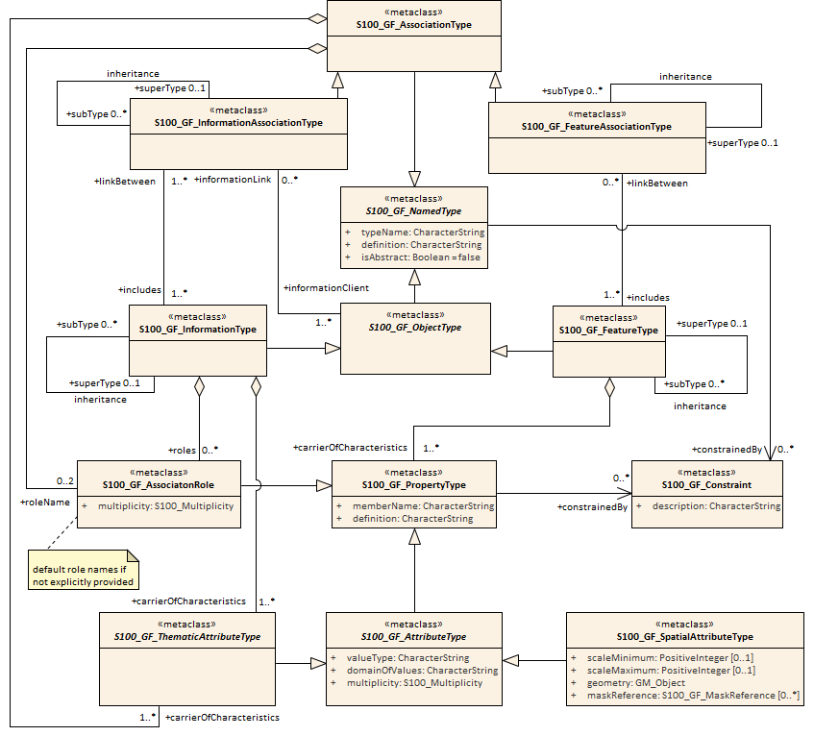
Figure 3-1 – The General Feature Model

The purpose of the GFM
The GFM is a basis for the classification of features and information types and their properties. The GFM also acts as the basis for the structure of Feature Catalogues.

The main structure of the GFM
Figure 3-1 shows a UML model of the S-100 GFM.
The following clauses define the elements of the GFM.

S100_GF_NamedType
The class S100_GF_NamedType is not realized from ISO 19109 but is introduced specifically for the S-100 GFM. It is an abstract super-class of the classes S100_GF_ObjectType and S100_GF_AssociationType. The intention in introducing this class is to show the commonality between object types and association types within S-100. Both types are core identifiable objects of S-100 data Schemas.

Table 3-1— S100_GF_NamedType
Role Name | Name | Description | Mult. | Type
Class | S100_GF_NamedType | Abstract base class for object types and association types within the GFM | - | -
Attribute | typeName | Name of the named type. The name shall be unique within a namespace | 1 | CharacterString
Attribute | definition | Definition that describes the named type | 1 | CharacterString
Attribute | isAbstract | If true, the named type acts as an abstract supertype. It is not possible to create an instance of an abstract type | 1 | Boolean
Role | constrainedBy | The role specifies that a constraint is made on the named type | 0..* | S100_GF_Constraint

S100_GF_ObjectType
The class S100_GF_ObjectType is not realized from ISO 19109 but is introduced specifically for the S-100 GFM. It is an abstract super-class of the classes S100_GF_FeatureType and S100_GF_InformationType. The intention in introducing this class is to show the commonality between feature types and information types in particular the ability of these classes to be linked to information types by means of an information association.
Table 3-2— S100_GF_ObjectType
Role Name | Name | Description | Mult. | Type
Class | S100_GF_ObjectType | Abstract base class for object types within the GFM | - | -
Role | informationLink | Link to an information association that describes the relationship to an instance of an information type | 0..* | S100_GF_Information‌AssociationType

S100_GF_FeatureType
The class S100_GF_FeatureType is a realization of the ISO 19109 class GF_FeatureType. It differs from the ISO class in the following ways:
- It is a sub-type of the class S100_GF_NamedType;
- It does not realize the Generalization and Specialization associations with the class GF_InheritanceRelation. Instead, the class has an association with itself with the roles subType and superType. GF_InheritanceRelation is not realized in the S-100 GFM;
- The multiplicity of the superType is 0..1 to represent the concept that a feature may have a maximum of one superType. This is in order to prevent multiple-inheritance in S-100;
- The multiplicity of the role carrierOfCharacteristics with S100_GF_PropertyType (the S-100 realization of GF_PropertyType) is changed from 0..* to 1..*. An S-100 feature must have properties.
Table 3-3— S100_GF_FeatureType
Role Name | Name | Description | Mult. | Type
Class | S100_GF_FeatureType | A type for an abstract representation of a real world phenomenon | - | -
Role | superType | The more generic feature type from which this feature type is derived | 0..1 | S100_GF_FeatureType
Role | subType | The more specific feature types which are derived from this feature type | 0..* | S100_GF_FeatureType
Role | linkBetween | A link to a feature association that specify the relationship between one feature type and the same or another feature type | 0..* | S100_GF_FeatureAssociationType
Role | carrierOfCharacteristics | Attributes and roles that describe the characteristics of a feature type | 1..* | S100_GF_PropertyType

S100_GF_PropertyType
The class S100_GF_PropertyType is a realization of the ISO 19109 class GF_PropertyType. It differs from the ISO class in the following ways:
- The multiplicity of the association with S100_GF_FeatureType is changed from 1 to 1..*. This change represents the way that features and properties are described in the S-100 Feature Catalogue. Property type definitions can be used in one or more feature type definitions;
- The association type of the association with S100_GF_FeatureType is changed from composition to aggregation as a result of the change in multiplicity described above.
Table 3-4 — S100_GF_PropertyType
Role Name | Name | Description | Mult. | Type
Class | S100_GF_PropertyType | Abstract base class for all properties of a feature type. These are attributes and roles | - | -
Attribute | memberName | Name of the attribute or role | 1 | CharacterString
Attribute | definition | Description of the attribute or role of the feature type | 1 | CharacterString
Role | constrainedBy | The role specifies that a constraint is made on the property | 0..* | S100_GF_Constraint

S100_GF_AttributeType
The class S100_GF_AttributeType is the S-100 realization of GF_AttributeType. It is largely identical to the ISO 19109 class but differs in the following way:
- The association attributeOfAttribute is not realized in the S-100 GFM. S-100 introduces, instead, the concept of complex attributes. Complex attributes are described further in ISO 19109 subclause 7.4.
Table 3-5— S100_GF_AttributeType
Role Name | Name | Description | Mult. | Type
Class | S100_GF_‌AttributeType | Abstract base class for all attributes of feature types. In this model are two sub classes: thematic attributes and spatial attributes | - | -
Attribute | valueType | The data type of the attribute value | 1 | CharacterString
Attribute | domainOfValues | Description of a set of values. For codelist types this may be a URI identifying a dictionary or “vocabulary” | 1 | CharacterString
Attribute | multiplicity | The number of instances of the attribute that may be associated with a single instance of a feature type | 1 | S100_Multiplicity

S100_GF_AssociationRole
The class S100_GF_AssociationRole is the S-100 realization of the ISO 19109 class GF_AssociationRole.
Table 3-6 — S100_GF_AssociationRole
Role Name | Name | Description | Mult. | Type
Class | S100_GF_ AssociationRole | A role used in an association | - | -
Attribute | multiplicity | The number of objects that may be associated within the association | 1 | S100_Multiplicity

GF_Operation
The class GF_Operation is not realized in the S-100 GFM because S-100 supports only the data transfer model. Datasets cannot contain operations.

S100_GF_AssociationType
The class S100_GF_AssociationType is the S-100 realization of the ISO 19109 class GF_AssociationType. It differs from the ISO 19109 class in the following way:
- The ISO 19109 GFM models GF_AssociationType as a subtype of the class GF_FeatureType. This is done for reasons which are set out in Note 1 of ISO 19109 clause 7.3.9. The S-100 model does not model the class as a subtype of S100_GF_FeatureType. Within S-100 associations between feature types are not considered abstractions of real world phenomena. The result of this approach to modelling the GFM is that the only properties associations can have are thematic attributes.
- The multiplicity of roleName is 0..2 instead of 1..*. The lower bound of 0 means the role is one of the default roles “source” or “target” and this is obvious from the Application Schema’s semantics of the association type’s name and the names of the participating feature or information classes. The upper bound expresses the constraint that S-100 does not allow associations with more than two participating classes.
Table 3-7— S100_GF_AssociationType
Role Name | Name | Description | Mult. | Type
Class | S100_GF_AssociationType | Abstract base class for feature associations and information associations | - | -
Role | carrierOfCharacteristics | The thematic attributes that describes the association | 0..* | S100_GF_ThematicAttributeType
Role | roleName | The roles that describes the ends of the association | 0..2 | S100_GF_AssociationRole

S100_GF_InformationType
S100_GF_InformationType is the class for information types within S-100. An information type is an identifiable object that can be associated with features in order to carry information particular to the associated features. An example of an information type might be a Chart Note. Information types can also be associated with each other. This could be done where there is further supplementary information that is relevant to the information type or where there is a need to translate the information. For example a primary information object carrying a Chart Note may contain text in English and an associated supplementary information object may carry the same text in German.
The characteristics of information types shall be carried by thematic attribute types only. Therefore, S100_GF_InformationType is associated with only S100_GF_ThematicAttributeType rather than the more generic class S100_GF_PropertyType. The associations to information types are modelled by means of the type S100_InformationAssociationType.

Table 3-8 — S100_GF_InformationType
Role Name | Name | Description | Mult. | Type
Class | S100_GF_‌Information‌Type | A type for an identifiable object carrying supplementary information for other objects | - | -
Role | superType | The more generic information type from which this information type is derived | 0..1 | S100_GF_ InformationType
Role | subType | The more specific information types which are derived from this information type | 0..* | S100_GF_ InformationType
Role | linkBetween | A link to an information association that specifies the relationship between one object type and this information type | 0..* | S100_GF_Information‌AssociationType
Role | carrierOfCharacteristics | Thematic attributes that describe the characteristics of an information type | 1..* | S100_GF_Thematic‌AttributeType
Role | roles | Roles for associations to other information type that supplying supplementary information | 0..* | S100_GF_AssociationRole

S100_GF_FeatureAssociationType
The class S100_GF_FeatureAssociationType is not realized from ISO 19109 but is introduced specifically for the S-100 GFM. The reason for this is that in S-100 two types of associations are distinguished: feature associations and information associations. They are both semantically different and different in the model. This class describes the feature association. A feature association is the description of the relationship between two instances of feature types. It can be characterized by thematic attributes and has normally two roles. The roles describe the ends of the relationship since such relationship is usually not symmetric.
Table 3-9— S100_GF_FeatureAssociationType
Role Name | Name | Description | Mult. | Type
Class | S100_GF_Feature‌AssociationType | A class for the description of a relationship between two feature types | - | -
Role | superType | The more generic feature association from which this feature association is derived | 0..1 | S100_GF_Feature‌Association‌Type
Role | subType | The more specific feature associations which are derived from this feature association | 0..* | S100_GF_Feature‌Association‌Type
Role | includes | The feature types which are included in this relationship | 1..* | S100_GF_FeatureType

S100_GF_InformationAssociationType
The class S100_GF_InformationAssociationType is not realized from ISO 19109 but is introduced specifically for the S-100 GFM. The reason for this is that in S-100 two types of associations are distinguished: feature associations and information associations. They are both semantically different and different in the model. This class describes the information association. An information association is the description of the relationship between an arbitrary object and an information type that supplies additional information for that object. The relationship can be characterized by thematic attributes and a role.
Table 3-10— S100_GF_InformationAssociationType
Role Name | Name | Description | Mult. | Type
Class | S100_GF_‌Information‌AssociationType | A class for the description of a relationship between an object and an information type | - | -
Role | superType | The more generic information association from which this information association is derived | 0..1 | S100_GF_‌InformationAssociationType
Role | subType | The more specific feature associations which are derived from this feature association | 0..* | S100_GF_‌InformationAssociationType
Role | includes | The information type that is included in the relationship | 1..* | S100_GF_InformationType
Role | informationClient | The object types that act as client in the information association | 1..* | S100_GF_ObjectType

S100_GF_Constraint
The class S100_GF_Constraint is a realization of the ISO 19109 class GF_Constraint with an association to S100_GF_NamedType instead of the ISO 19109 association to GF_Feature_Type.
Table 3-11— S100_GF_Constraint
Role Name | Name | Description | Mult. | Type
Class | S100_GF_ Constraint | Class for constraints that may be associated with named types or their properties | - | -
Attribute | description | The constraint described in natural language and/or in formal notation | 1 | CharacterString

Attributes of feature types

Introduction
This clause describes in more detail the role of attributes of features and information types.
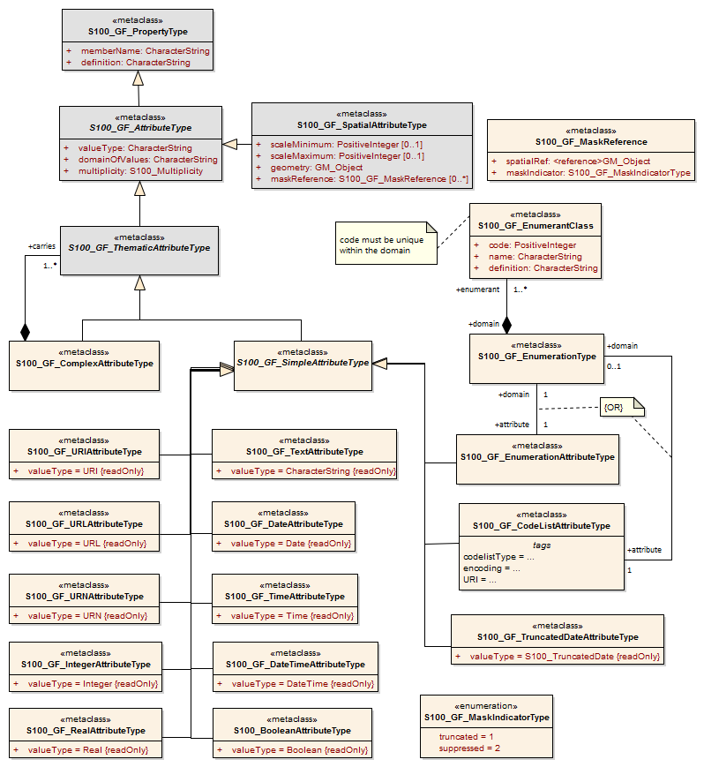
Figure 3-2 — Attributes

S100_GF_ThematicAttributeType
The class S100_GF_ThematicAttributeType is a realization of the ISO 19109 class GF_ThematicAttributeType. Thematic attribute types carry descriptive characteristics of objects other than those specified in ISO 19109 clauses 7.4.3 – 7.4.7. This class differs from the ISO 19109 class in the following ways:
- GF_ThematicAttributeType is defined in ISO 19109 as a concrete class. The S-100 GFM realization is an abstract class with two concrete subclasses – S100_GF_SimpleAttributeType and S100_GF_ComplexAttributeType.
- Temporal information shall have their value type defined by the types Date, Time, DateTime, S100_TruncatedDate or complex structures using combinations of the primitive temporal types.
Table 3-12— S100_GF_ThematicAttributeType
Role Name | Name | Description | Mult. | Type
Class | S100_GF_ ThematicAttributeType | Abstract base class for all attributes other than spatial attributes | - | -

S100_GF_ComplexAttributeType
The class S100_GF_ComplexAttributeType is introduced in the S-100 GFM. Complex attributes are a composition of other attributes either simple or complex.

S100_GF_SimpleAttributeType
The class S100_GF_SimpleAttributeType is introduced in the S-100 GFM. A simple attribute type carries a descriptive characteristic of a named type.

S100_GF_SpatialAttributeType
The class S100_GF_SpatialAttributeType is a realization of the ISO 19109 class GF_SpatialAttributeType. A spatial attribute type shall have a GM_Object as its value type. GM_Object and its sub-types are defined in the Spatial Schema, S-100 Part 7.
NOTE: The class S100_GF_SpatialAttributeType is only partially implemented in the Feature Catalogue described in S-100 Part 5 and in the encodings described in Part 10.
Table 3-13— S100_GF_SpatialAttributeType
Role Name | Name | Description | Mult. | Type
Class | S100_GF_ SpatialAttributeType | Class representing a spatial attribute, which shall be used to express spatial characteristics of a feature type | - | -
Attribute | scaleMinimum | The denominator of the smallest scale for which the referenced geometry can be used for the instance of the feature type (for example, for depiction) | 0..1 | PositiveInteger
Attribute | scaleMaximum | The denominator of the largest scale for which the referenced geometry can be used for the instance of the feature type (for example, for depiction) | 0..1 | PositiveInteger
Attribute | geometry | The object that describes the geometry of an instance of a feature type | 1 | GM_Object
Attribute | maskReference | Reference indicating masked or truncated spatial primitives or objects | 0..* | S100_MaskReference

Masking or truncation shall be indicated by providing the identifiers of the masked or truncated primitives and an indicator of whether the referenced primitive is masked or truncated in maskReference attributes. The structure of the maskReference attribute is defined by the type S100_GF_MaskReference, shown in Table 3-14 below.
The implementation of mask references in different S-100 formats is specified in the respective data format specifications (Part 10a for the ISO 8211 data format and Part 10b for the GML format) and may use constructs built into the core specification. For example, the S-100 GML format uses the GML type ReferenceType with restrictions on allowed values of the xlink:href and xlink:role attributes; the ISO 8211 format uses unsigned integers containing the record identifier of a spatial object and the numeric code of the mask indicator value.
The spatial objects referenced in the masking attribute must be among the components of the GM_Object that constitutes the spatial object referenced by the same instance of the spatial attribute. They may be components at any level, for example, components of components, etc. (In other words, the masked or truncated geometry must be part of the geometry of that particular instance of the spatial attribute.)
Product Specifications should restrict the use of masking to specific spatial types if needed, for example, to curves.
Table 3-14— S100_GF_MaskReference
Role Name | Name | Description | Mult. | Type
Class | S100_GF_MaskReference | Reference to a masked or truncated spatial primitive. Model is based on gml:Reference but limits the allowed attributes and makes the identifier and role mandatory | - | -
Attribute | spatialRef  (alias xlink:href) | Identifier of a spatial primitive | 1 | <(reference>GM_Object
Attribute | maskIndicator  (alias xlink:role) | Indicates whether a spatial primitive is masked or truncated by the dataset limit | 1 | Enumeration S100_GF_MaskIndicatorType

Table 3-15— S100_GF_MaskIndicatorType
Item | Name | Description | Code | Remarks
Enumeration | S100_GF_MaskIndicatorType | Indicates masking or truncation at the dataset limit | - | -
Literal | truncated | The spatial primitive is truncated at the dataset limit | 1
Literal | suppressed | Portrayal of the spatial primitive is suppressed | 2

GF_TemporalAttributeType
The ISO 19109 class GF_TemporalAttributeType is not realized explicitly in the S-100 GFM. Temporal information shall be modelled using the thematic attribute type S100_GF_ThematicAttributeType (see clause 3-6.4.4 for more details).

GF_MetadataAttributeType
The ISO 19109 class GF_MetadataAttributeType is not realized explicitly in the S-100 GFM. Metadata types shall be modelled using complex thematic attributes which realize types from the S-100 Part 4a metadata component. The complex thematic attributes shall be defined in a Feature Catalogue.

GF_QualityAttributeType
The ISO 19109 class GF_QualityAttributeType is not realized explicitly in the S-100 GFM. Quality metadata types shall be modelled using complex thematic attributes which realize types from the S-100 Part 4c Appendix 4c-A Data Quality. The complex thematic attributes shall be defined in a Feature Catalogue.

GF_LocationAttributeType
The ISO 19109 class GF_LocationAttributeType is not realized in the S-100 GFM.

S100_TruncatedDateAttributeType
The class S100_TruncatedDateAttributeType is intended for modelling date values with one or more of the more significant components omitted. This allows partial dates to be used, for example, for recurring periods.

S100_GF_CodelistAttributeType
The class S100_GF_CodelistAttributeType is introduced in the S-100 GFM for modelling S-100 codelists. Codelist attributes must be associated to either an enumeration (for open enumeration codelists) or a dictionary (for open and closed dictionary codelists) but not both. The structure of the dictionary is defined by an external specification.
Table 3-16— S100_GF_CodelistAttributeType
Role Name | Name | Description | Mult. | Type | Remarks
Class | S100_GF_ CodelistAttributeType | Abstract base class for S100_Codelist attributes | - | - | -
Tag | codelistType | Type of codelist | 1 | CharacterString | Must be one of:  open enumeration  open dictionary  closed dictionary
Tag | URI | Identifies the dictionary for open or closed dictionary codelists | 0..1 | CharacterString | Only for open or closed dictionary codelists
Tag | encoding | Encoding hint for extra values | 0..1 | CharacterString | Only for open enumeration or open dictionary codelists

S100_GF_EnumerationType
S100_GF_EnumerationType and S100_GF_EnumerantClass together model the enumerations defining the allowed values for an enumeration attribute and their semantics. An instance of an enumeration type may define the set of allowed values for an enumeration or codelist attribute, or both.

Relationships between named types

Introduction
This subclause describes relationships between object types in more detail. Relationships are classified as follows:
- Generalisation / Specialisation of feature types and information types.
- Associations between feature types and information types.

GF_InheritanceRelation
The class GF_InheritanceRelation is not realized in the S-100 GFM but object inheritance is allowed through the use of an identical association on the class S100_GF_FeatureType and the class S100_GF_InformationType (see Figure 3-3). The multiplicity of the superType end of the association is such that a subtype may have only one supertype. This is to prevent the modelling of multiple inheritance. The inheritance relation association is modelled at the level of the concrete class rather than on the abstract class S100_GF_NamedType. This prevents a feature type inheriting from an information type and vice versa.
Inheritance associations exist only between named types (classes) and not between named type instances (that is entities occurring in a dataset).
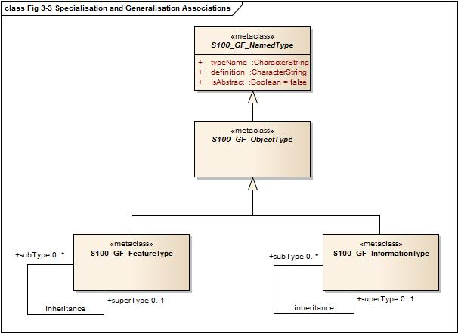
Figure 3-3 — Specialisation and Generalisation Associations

S100_GF_AssociationType
Associations are defined by the class S100_GF_AssociationType with two roles and a definition. The ISO 19109 classes GF_AggregationType, GF_SpatialAssociationType, and GF_TemporalAssociationType are not realized explicitly in the S-100 GFM. These classes can be used only if an association is allowed to carry properties. The ISO 19109 GFM allows this because GF_AssociationType is a sub-type of GF_FeatureType. However, S100_GF_AssociationType is not a sub-type of S100_GF_FeatureType.

Associations to information types
An association between S100_GF_ObjectType and S100_GF_InformationType is introduced in the S-100 GFM. The role additionalInformation is the default for this association in the S-100 GFM and means that additional information is available for a named type.

Default names for association ends
Application Schemas may specify names for association ends (role names). If names are not explicitly provided, the following defaults shall be used.
- If only one end of an association is given an explicit name “<rolename>”, the other end shall have the default name “inv_<rolename>”.
- If neither end of the association is given an explicit name, the default role name is “the<target class name>” in which the target class is referenced from the source class.
- The above rules may not result in a distinct name for each association end in an Application Schema, so Product Specifications may define different or additional rules if needed.
- If standard names are desired, the following defaults may be used instead of those listed above.
  - The role “additionalInformation” is a default role name for associations from feature to information types.
  - Feature/feature or information/information associations navigable in only one direction may use the default end names “source” and “target”. The name “associatedWith” may be used at both ends of a bidirectional association.
Product Specifications may mix individual and standard defaults but must be unambiguous about which name applies to any particular association end.

Behaviour of feature types
The behaviour of feature types is described by operations that may be performed upon or by instances of a feature type. Operations apply only to the interoperability model and do not apply to the data transfer model.

Constraints
Constraints may be introduced to ensure the integrity of the data. Constraints restrict the freedom in an application to prevent creation of erroneous data by specifying combinations of data that are either allowable or not allowable. An Application Schema shall identify constraints in an unambiguous manner.
Only named types and properties may have constraints.

Rules for Application Schema (ISO 19109 Clause 8)

The application modelling process (ISO 19109 Clause 8.1)
The Application Schema serves two purposes:
- It achieves a common and correct understanding of the content and structure of data within a particular application field.
- Secondly, it may provide a computer readable Schema for applying automated mechanisms for data management.
The two roles imply a stepwise process for creating an Application Schema. The steps can be briefly described as:
- Surveying the requirements from the intended field of application (Universe of Discourse)
- Making a conceptual model of the application with concepts defined in the GFM. This task consists of identifying feature types, their properties and constraints.
- Describing elements of the Application Schema in a formal modelling language where necessary. S-100 Application Schemas shall be described using the UML according to rules defined in this part of S-100.
- Integrating the formal Application Schema with other standardized Schemas, (Spatial Schema, Quality Schema, etc.) into a complete Application Schema.

The Application Schema (ISO 19109 Clause 8.2)

Conceptual Schema language for Application Schemas
If a conceptual language is used to design a S-100 Application Schema, then this must be UML.

Main rules
The data structures of the Application Schema shall be modelled in the Application Schema.
All classes used within an Application Schema for data transfer shall be instantiable. This implies that the integrated class must not be stereotyped <<interface>>.

Identification of Application Schemas
- The identification of each Application Schema shall include a name and a version. The inclusion of a version ensures that a supplier and a user agree on which version of the Application Schema describes the contents of a particular dataset. A system of defining unique names and versions for S-100 Application Schemas shall be defined.
- In UML, an Application Schema shall be described within a PACKAGE, which shall carry the name of the Application Schema and the version stated in the documentation of the PACKAGE.

Documentation of an Application Schema
- An Application Schema shall be documented. A means of documenting Application Schemas for S-100 shall be defined in order to ensure consistency across S-100 Product Specifications.
- The documentation of an Application Schema in UML may utilise the documentation facilities in the software tool that is used to create the Application Schema, if this information can be exported.
- If a CLASS or other UML component corresponds to information in a Feature Catalogue, the reference to the Catalogue shall be documented.
- Documentation of feature types in an Application Schema shall be in a Catalogue with a structure derived from the GFM, such as in a Catalogue in accordance with S-100 Part 5. This could be in text format or XML accompanied by a style sheet (XSLT) used to create a text version.

Rules for Application Schema in UML (ISO 19109 Clause 8.3)

Main rules (ISO 19109 Clause 8.3.1)
The main rules for Application Schemas in UML are:
- An instance of S100_GF_NamedType shall be implemented as a CLASS.
- An instance of S100_GF_ObjectType shall be implemented as a CLASS.
- An instance of S100_GF_FeatureType shall be implemented as a CLASS.
- An instance of S100_GF_InformationType shall be implemented as a CLASS
- An instance of S100_GF_FeatureAssociationType has the role of linkBetween in association to instances of S100_GF_FeatureType being implemented as CLASSes. It shall be implemented as one of the following cases:
  - Case 1: An instance of S100_FeatureAssociationType that is not associated with any instances of S100_GF_ThematicAttributeType shall be implemented as an ASSOCIATION between these CLASSes.
  - Case 2: An instance of S100_FeatureAssociationType that is associated with one or more instances of S100_GF_ThematicAttributeType shall be implemented as an ASSOCIATION CLASS; the associated instances of S100_GF_ThematicAttributeType shall be implemented as ATTRIBUTES of the ASSOCIATION CLASS.
- An instance of S100_GF_InformationAssociationType has the role of informationLink in association to instances of S100_GF_FeatureType or S100_GF_InformationType being implemented as CLASSES. It shall be implemented one of the following cases:
  - Case 1: An instance of S100_InformationAssociationType that is not associated with any instances of S100_GF_ThematicAttributeType shall be implemented as an ASSOCIATION between these CLASSes.
  - Case 2: An instance of S100_InformationAssociationType that is associated with one or more instances of S100_GF_ThematicAttributeType shall be implemented as an ASSOCIATION CLASS; the associated instances of S100_GF_ThematicAttributeType shall be implemented as ATTRIBUTES of the ASSOCIATION CLASS.
- An instance of S100_GF_AttributeType shall be implemented as an ATTRIBUTE.
- An instance of S100_GF_SimpleAttributeType shall be implemented as an ATTRIBUTE.
- An instance of S100_GF_ComplexAttributeType shall be implemented as a CLASS. The instantiated CLASS shall have one or more instances of S100_GF_SimpleAttributeType and/or S-100_GF_ComplexAttributeType as its ATTRIBUTE(s).
- An instance of the association inheritanceRelation shall be represented by a UML GENERALISATION relationship.

Domain profiles of standard Schemas in UML (ISO 19109 Clause 8.4)

Rules for adding information to a standard Schema
Standard Schemas shall not be extended within Application Schemas. Standard Schemas are those that are documented in S-100, for example the Spatial Schema, Feature Catalogue Schema etc.

Restricted use of standard Schemas
For some standard Schemas, for example S-100 Part 7 (Spatial Schema), it is possible to redefine the Schema in such a way that only selected parts of the Schema will be used, and only some of the definitions of classes and relationships will be used.
- Specification of a restricted profile of a standard Schema shall be described in a new UML package by copying the actual definitions (classes and relationships) from the standard Schema. Attributes and operations within classes may be omitted.
- Reduction of a standard Schema shall be in accordance of the conformance clause given for the actual standard.

Rules for use of metadata Schema (ISO 19109 Clause 8.5)
The metadata Schema defined in S100 Part 4 is an application Schema for metadata data sets. Metadata are data describing and documenting data. Metadata for geographic data typically provides information about their identification, extent, quality, spatial and temporal aspects, spatial reference and distribution.
Metadata types shall be implemented as complex attributes that realize elements from S100 Part 4. Thus metadata attributes shall be thematic attribute types.

Temporal rules (ISO 19109 Clause 8.6)
S-100 does not include a profile of ISO 19108. Temporal attributes shall be modelled using the types Date, Time or DateTime, S100_TruncatedDate, or complex attributes using combinations of these temporal types. Use of these types makes the attribute an instance of S100_GF_SimpleAttributeType or S100_GF_ComplexAttributeType, as appropriate.

Spatial rules (ISO 19109 Clause 8.7)

General spatial rules (ISO 19109 Clause 8.7.1)
The value domain of spatial attribute types shall be in accordance with the specifications given by S-100 Part 7, which provides conceptual Schemas for describing the spatial characteristics of features and a set of spatial operators consistent with these Schemas.
S-100 Part 7 explicitly excludes topological primitives and consequently any topology rules set out in clause 8.7 of ISO 19109 are not relevant in this profile.

Spatial attributes
- Spatial characteristics of a feature shall be described by one or more spatial attributes. In an Application Schema, a spatial attribute is a subtype of a feature attribute (see 5.3), and the taxonomy of its values is defined in the S-100 Part 7.
- A spatial attribute shall be represented in an Application Schema in either of two ways:
- Case 1: as an ATTRIBUTE of a UML CLASS that represents a feature, in which case the ATTRIBUTE shall take one of the spatial objects defined in the Spatial Schema, ISO 19107, as the data type for its value; or
- Case 2: as a UML ASSOCIATION between the class that represents a feature and one of the spatial objects defined in the Spatial Schema, ISO 19107.
- A spatial attribute shall take a spatial object as its value. Spatial objects are classified as geometric objects, which are sub-classed as primitives, complexes or aggregates (for geometric objects). The value types of spatial attributes must be the types described in Part 7, or their subtypes.

Spatial Quality
The positional quality of a spatial object shall be described by a one way association to a S100_GF_InformationType which is associated with a S100_GF_ThematicAttributeType carrying positional accuracy.

Geometric aggregates and complexes to represent spatial attributes of features

Introduction
The spatial configuration of many features cannot be represented by a single geometric primitive. The types GM_Aggregate and GM_Complex support the representation of such features as collections of geometric objects.

Geometric aggregates
The spatial profile of S-100 only supports the GM_Multipoint geometric aggregate type. GM_Multipoint shall be used as the value of a spatial attribute that represents a feature as a set of points.

Geometric complexes
Geometric complexes are used to represent the spatial characteristics of a feature as a set of connected geometric primitives. In addition, instances of GM_Complex allow geometric primitives to be shared by the spatial attributes of different features. There are no explicit links between the GM_Primitives in a GM_Complex; the connectivity between the GM_Primitives can be derived from the coordinate data.
- A GM_Complex shall be used as the value for a spatial attribute that represents a feature as a collection of connected GM_Objects, which are disjoint except at their boundaries. Subclasses of GM_Complex may be specified to constrain the structure of the GM_Complex used to represent a particular spatial configuration.
- Features that share elements of their geometry shall be represented as GM_Complexes that are subcomplexes within a larger GM_Complex.

Geometric composites
A geometric composite is a geometric complex that has all the properties of a geometric primitive except that it is composed of smaller geometric primitives of the same kind. Geometric composites are used to represent complex features that are composed of smaller geometric objects that have the same kind of geometry. A GM_Composite shall be used to represent a complex feature that has the geometric properties of a geometric primitive.

Features sharing geometry
Different features can share, partly or completely, the same geometry when they appear to occupy the same position. To share a common geometry, spatial feature attributes must share one or more GM_Objects.
There are two ways to share geometry. Complete sharing occurs when two feature instances both take the same instance of a GM_Object as the value of a spatial attribute. This can be required, or precluded, by stating a constraint in the Application Schema. In the absence of such constraints, it may be done whenever necessary.
- An Application Schema may require instances of two or more feature types to share their geometry completely by including a constraint that the GM_Objects representing the features must be equal.
- An Application Schema may preclude instances of two or more feature types from sharing their geometry completely by including a constraint that the GM_Objects representing the features are not equal.

Cataloguing rules (ISO 19109 Clause 8.8)

Introduction (ISO 19109 Clause 8.8.1)
A Feature Catalogue is a repository that describes real world phenomena of significance to a particular domain. A feature cataloguing methodology provides the details about the organisation of the data that represents these phenomena in categories so that the resulting information is as unambiguous, comprehensible and useful as possible.

Application Schema based on a Feature Catalogue (ISO 19109 Clause 8.8.2)
An S-100 Application Schema shall be completely constructed by the definitions provided by a Feature Catalogue implementing the S-100 Feature Catalogue profile.

Character encoding
The character encoding used in a dataset shall be defined in the Application Schema. Where more than one character encoding is used the Application Schema shall document how they are used in the dataset.

Codelists
Application Schemas which use an attribute of codelist type shall include a CLASS with tags as specified in Table 3-17 below. The codelist types are described in Part 1.
Table 3-17 — Tags for codelist types
Codelist type | Tags and values
open enumeration | codelistType=open enumeration  encoding=other: [something]
closed dictionary | codelistType=closed dictionary  URI=<dictionary URL>
open dictionary | codelistType=open dictionary  URI=<dictionary URL>  encoding=other: [something]

The normative form of the “other: [something]” encoding shall be a character string in the format specified below:
The word ‘other’ followed by a colon and a single space character (that is ‘other: ’ without quotes), followed by one or more alphanumeric strings separated by single spaces.
The normative pattern specifying the portion following ‘other: ’ is specified as (using XML Schema 1.0/1.1 patterns):
[a-zA-Z0-9]+( [a-zA-Z0-9]+)*
Note that the left parenthesis is followed by a single space and the pattern ends with the asterisk.
Examples:
Table 3-18 — Examples of “extra” values for codelist attributes
other: loxodromic | allowed
other: Seeschifffahrtsstraßen Ordnung | not allowed (contains the character ß which is not in the allowed set)
other: German Shipping Regulations | allowed
other: German Shipping Regulations | not allowed (2 consecutive spaces)
German Shipping Regulations | not allowed (does not begin with “other: “)
other: 287 | allowed
other: 1,3,5-Trinitroperhydro-1,3,5-triazine | not allowed (hyphen and comma characters are not in the allowed set)

Application Schema for Coverages (informative)

Introduction
This rule set for Application Schemas is aimed at Application Schemas for feature oriented data. However, Application Schemas may also be defined for coverages.
This section includes examples of how Application Schemas may be defined for imagery and gridded data. The components of the Application Schemas are defined in ISO 19123 not ISO 19109. However, a coverage may be based on feature type geometries and, in such cases, is conceptually similar to a feature collection. Such feature oriented coverages are discussed below.

Gridded Data
This Application Schema defines a quadrilateral grid coverage with associated metadata. The metadata is generically referenced to ISO 19115-1 and 19115-2. A specific choice of metadata has not been made in this Schema. This Schema can serve for both "matrix" and "raster" data according to the metadata chosen.
The gridded data consists of a single feature - the "image" or "matrix" together with associated metadata taken from MD_Metadata (or MI_Metadata). The CV_Coverage (that is, its relevant sub-type, for example, CV_ContinuousQuadrilateralGridCoverage) serves as the spatial attribute of the gridded data set. It defines an area that is "covered" by the coverage function. For the continuous coverage defined in this Application Schema, the coverage function returns a value for every point in the area covered based on an interpolation function. The Grid Value Matrix is a set of values which drives the interpolation function. It this case the value matrix is a grid traversed by a linear scan (x,y) traversal rule. The spatial referencing is defined by the coordinate reference system.
This template Application Schema supports the majority of imagery and gridded data applications.

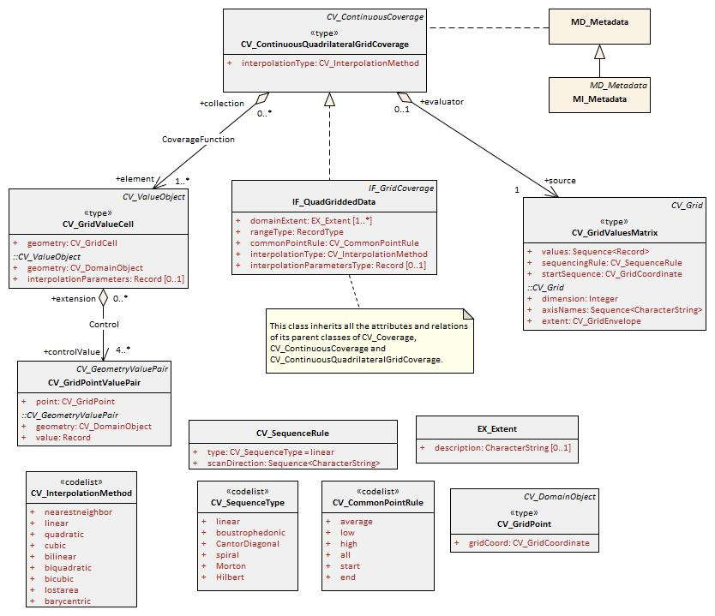
Figure 3-4 – Template Application Schema for a Quadrilateral Grid Coverage

Variable Cell Size Grid
This Application Schema describes a grid of variable cell size (ISO 19123). The traversal order is the Morton order in order to permit support of three (or more) dimensions. This is of particular use for hydrographic data where large volumes of sonar data result in an extensive bottom cover in a 3D grid, but where the cells of similar depth can easily be aggregated.

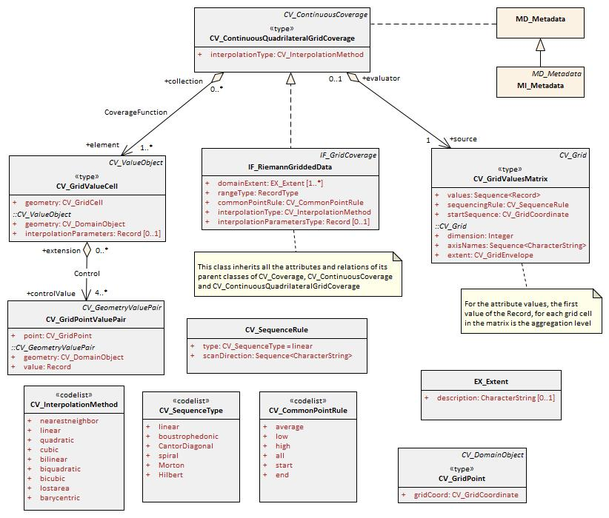
Figure 3-5 – Template Application Schema for a Reimann Grid Coverage

Feature Oriented Image
All gridded data sets are feature oriented, in that a coverage is a subtype of a feature. This means that an entire gridded data set can be considered to be a single feature. A feature structure can be applied to gridded data in two different ways. First, a discrete coverage can carry a feature code as an attribute. For example, a coverage corresponding to the postal code system will have discrete values for each postal code, yet still cover the country completely. The only difference in the Application Schema is a relationship between the discrete coverage and the feature.
The template Application Schema in Figure 3-6 below depicts both the “discrete point” and “discrete grid point” coverage classes. The typical Product Specification would choose one or the other (or both) depending on the type of coverage needed.
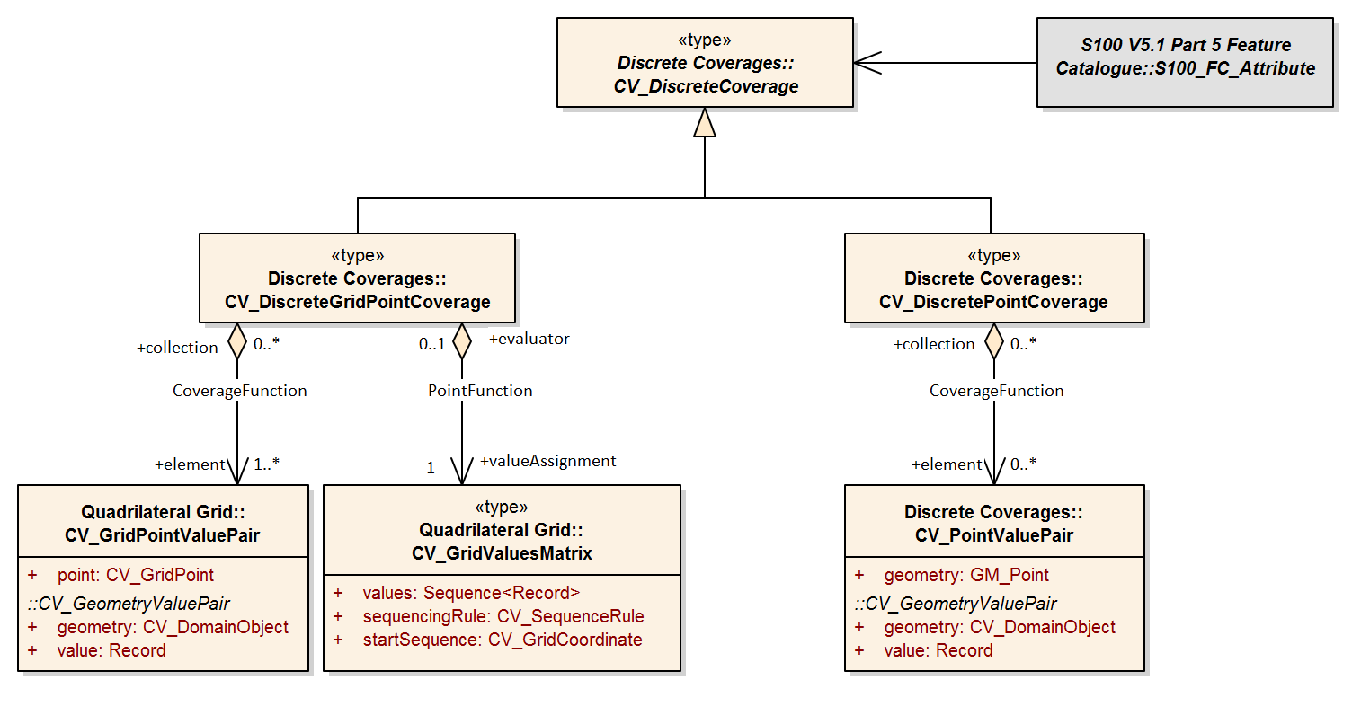
Figure 3-6 – Feature oriented discrete coverage
The second method of establishing a feature structure is to develop a composite data set that contains many separate but adjoining coverages. The coverages may be continuous or discrete. This is very much like the way a "vector" data set is composed where each feature has its own geometry and attributes. In fact vector data may be mixed with coverage data in the same data set. The Application Schema simply allows multiple instances of feature.
Geometric elements such as grids may be shared between multiple features, and features may be related by composition or other relationships as allowed in the general feature model of ISO 19109. A complex feature may include both a continuous grid coverage and vector data such as a polygonal boundary. A feature oriented data set may contain both a continuous coverage of the ocean as collected by sonar, and point and line features corresponding to navigational aids. Topological primitives may relate all of the features. This allows for some interesting and useful structures. A Raster Nautical Chart may include additional vector data describing the navigational aids, hazards and danger zones, which are not "visible" in that they are not portrayed, but which are active in the use of the Raster Nautical Chart, so the mariner can determine whether a ship is within a danger zone, or perform other ECDIS functions.

S-100 Temporal Framework

Temporal definitions
S-100 does not include a complete profile of ISO 19108. Temporal attributes shall be modelled using the primitive types Date; Time or DateTime; S100_TruncatedDate; S100_IndeterminateDate; or complex attributes using combinations of these temporal types. Use of these types makes the attribute an instance of S100_GF_SimpleAttributeType or a component of an instance of S100_GF_ComplexAttributeType, as appropriate.
Time instants are usually defined either as UTC or as local time with standardized offset to UTC or time zone, using the Gregorian calendar. Therefore S-100 does not implement any of the ISO 19108 Section 5.3 Temporal Reference Systems provisions.
- An S-100 “instant”, in the ISO 19108 sense (ISO 19108 5.2.3.2), is implemented as a single S-100 Date, Time or DateTime (see S-100 Part 1, clause 1-4.5.3.10 S100_TM_Instant).
- An S-100 “period” (TM_Period ISO 19108 5.2.3.3) is implemented as a continuous interval between two S100_TM_Instants (see S-100 Part 1, clause 1-4.5.3.11), expressed as an appropriate complex attribute, for example fixedDateRange.
- S100_IndeterminateDate is an instant which lies within a defined period.
- An S100_TM_Instant specified using TruncatedDate can represent an infinite number of ISO 19108 instants.

Temporal relationships
S-100 does not implement full provision of ISO 19108’s temporal topology, nor temporal relative positions; however relationships between two S-100 instant and/or period values A and B shall be defined and described using the ISO 19108 TM_RelativePosition values as per Table 3-19 below. Only entries marked with (†) may be meaningfully defined when the S100_TM_Instant is an S100_IndeterminateDate expressed in indeterminate format with a bounded beginning or end.
Table 3-19 — Relationships between temporal values (from from ISO 19108 5.2.3.5 TM_Relative Position)
A~B | A (Single S100_TM_Instant) | A (Single S100_TM_Period)
B (Single S100_TM_Instant) | Before (A < B)  Equals (A = B)  After (A > B) | Before (A_{end}< B)†  EndedBy (A_{end}=B)  Contains (A_{begin}<B and A_{end}>B)  BegunBy (A_{begin} = B)  After (A_{begin} > B)†
B (Single S100_TM_Period) | Before (A<B_{start})†  Ends (A=B_{end})  Within (A>B_{begin} and A<B_{end})  Begins (B_{begin} = A)  After (A > B_{end})† | Before (A_{end} < B_{begin})†  Meets (A_{end} = B_{begin})  Overlaps (A_{begin}<B_{begin} and A_{end} > B_{begin} and A_{end} < B_{end})  Begins (A_{begin} = B_{begin} and A_{end} < B_{end})  BegunBy (A_{begin}=B_{begin} and A>B_{end})  During (A_{begin} > B_{begin} and A_{end} < B_{end})  Contains (A_{begin} < B_{begin} and A_{end} > B_{end})  Equals (A_{begin}=B_{begin} and A_{end} = B_{end})†  OverlappedBy (A_{begin} > B_{begin} and A_{begin} < B_{end} and A_{end} > B_{end})  Ends (A_{begin} > B_{begin} and A_{end} = B_{end})  EndedBy (A_{begin} < B_{begin} and A_{end} = B_{end})  MetBy (A_{begin} = B_{end})  After (A_{begin} > B_{end})†

S-100’s TruncatedDate enables regular time periods or instants to be defined. These are a union of a, potentially infinite, series of non-intersecting periods or instants. for example:
“2021---05” = { 2021-01-05, 2021-02-05, 2021-03-05, 2021-04-05, 2021-05-05, 2021-06-05, 2021-07-05, 2021-08-05, 2021-09-05, 2021-10-05,2021-11-05,2021-12-05}
Truncated dates allow a series of periods to be defined. The relationships definable between a single TM_Instant or TM_Period (A) with a set of periods defined by a date in Truncated Format (B) (that is, relationship A~B) are defined in Table 3-20 below (the quantifier “” means “for all” and refers to all TM_Periods within B (note some relationships (Before/After) may not be defined when B is a set of unbounded regular time periods).
Table 3-20 — Relationships between temporal values and truncated date
A~B | A (Single TM_Instant) | A (Single TM_Period)
B_{n} (Multiple TM_Periods) | Before (A < B_{start})  Within (A>=B_{begin} and A<=B_{begin}) for some B_{i}  After (A > B_{end}) ) | Before (A_{end}< B_{begin})  Within (A_{begin}>=B_{begin} and A_{end}<=B_{end}) for some B_{i}  After (A_{begin} > B_{end})

Interpretation of models of time intervals and period
The start and end instants of periods (and intervals) shall be included in the period (or interval) unless a Product Specification specifies a different interpretation. This is based on ISO 8601:2004 § 2.1.3 which defines time interval as “the part of the time axis delimited by two instants” and provides that “A time interval comprises all instants between the two limiting instants and, unless otherwise stated, the two limiting instants themselves”. Use of “before” or “after” attributes for intervals is not permitted.
The start and end instants are defined by the date/time component of smallest granularity. For example, if the month is the smallest component given in an end instant, the end instant is the whole month and the interval ends at the end of the last day of the month.
Examples: Applying this to encoding intervals using the reduced accuracy representation or the truncatedDate type, results in the interpretations in Table 3-21. The table also indicates how the special case of leap years can be handled.
Table 3-21 — Examples of periods
<S100_TruncatedDateAttributeType>  periodStart | ----01-- | 000000 on January 1 through 240000 on the 29th day of February in leap years and the 28th day of February in non-leap years
<S100_TruncatedDateAttributeType>  periodStart | year and day not encoded
<S100_TruncatedDateAttributeType>  periodEnd | ----02--
<S100_TruncatedDateAttributeType>  periodEnd | year and day not encoded
<S100_TruncatedDateAttributeType>  periodStart | ----0101 | 000000 on January 1 through 240000 on the 28th day of February each year
<S100_TruncatedDateAttributeType>  periodStart | year not encoded
<S100_TruncatedDateAttributeType>  periodEnd | ----0228
<S100_TruncatedDateAttributeType>  periodEnd | year not encoded
<S100_DateAttributeType>  dateStart | 20120105 | 000000 on January 5, 2012 through 240000 on June 18, 2012
<S100_DateAttributeType>  dateEnd | 20120618 | 000000 on January 5, 2012 through 240000 on June 18, 2012

Use of format-specific types for truncated dates
Data formats may utilise specific types as supported by that format in order to incorporate truncated values. Where this occurs the format description must specify the mapping between the S100_TruncatedDateAttributeType values and those of the format-specific types.
Example: An XML based encoding may use the gMonthDay simple attribute type (which is an XML Schema built-in type) as an equivalent representation for “December 17 each year”:
xs:gMonthDay: --12-17
This is equivalent to the value ----1217 in a data format which adheres strictly to S-100.

Instance Identifiers
Identifiers of instances should utilize the Maritime Resource Name (MRN) concept and namespace. The MRN namespace is administered by the International Association of Lighthouse Authorities (IALA) through the website http://mrnregistry.org, which also contains references to the full set of rules that apply to the MRN concept. The topmost namespace urn:mrn remains fixed, with subsequent name spaces separated by colons, and available through the application process explained on the website. Any organization wishing to issue MRN conformant identifiers should apply for a name space from IALA, or from an organization that already has a namespace registered.
For example, IHO applies for a namespace, and subsequently gives all member states a sub-namespace under the urn:mrn:iho namespace; for NOAA this could be urn:mrn:iho:us and for CHS this could be urn:mrn:iho:ca. NOAA and CHS would then administer their respective namespaces as needed and within the MRN rules.
The following rules apply to the MRN namespace.
The Namespace Specific String (NSS) of all URNs that use the "mrn" NID shall have the following structure:
<URN> ::= "urn:mrn:" <OID> ":" <OSS>
<OID> ::= 1*(ALPHA / DIGIT) ; Organizational ID
<OSS> ::= <OSNID> ":" <OSNS> ; Organizational specific string
<OSNID> ::= 1*(ALPHA / DIGIT / "-") ; Organizational specific namespace ID
<OSNS> ::= 1*<URN chars> ; Organizational specific namespace string

DIGIT ::= %x30-39 ; 0-9
ALPHA ::= %x61-7A ; a-z

Basics of the ABNF notation used:
" " literals (terminal character strings); terms not in quotes are non-terminals
/ alternatives
() indicates a sequence group, used as a single alternative or as a single repeating group
<a>*<b> indicates that the following term or group can repeat at least <a> and at most <b> times; default values are 0 and infinity, respectively
; comment
The entire URN is case-insensitive.
<URN chars> As defined in RFC2141
The process for assigning unique organizational IDs is managed by IALA. Details and application process can be found at <http://www.mrnregistry.org>.

Making use of instance identifiers
When it is required to enable the discovery of instances of the same thing between products, whether of the same Product Specification or between different Product Specifications, a minimum use of an instance identifier is needed. This instance identifier must be an attribute in all class instances of feature type or information type that need to be co-identified. The attribute must be called interoperabilityIdentifier and must be of data type URN.

